**WIND**

**Bibliografia**

# . Effects of Wind Disturbance on the Aerodynamic Performance of a Quadrotor MAV during Hovering;

# Effect of wind disturbance on the aerodynamic performance of coaxial rotors during hovering,” Measurement and Control, vol. 52, no. 5-6, pp. 665–674, 2019

# . D. Mellinger, A. Kushleyevand, and V. Kumar. Mixed-integer quadratic program trajectory generation for heterogeneous quadrotor teams. IEEE International Conference on Robotics and Automation, pages 477–483, 2012

# Influence of Aerodynamics and Proximity Effects in Quadrotor Flight

- aumenta o thrust

- componente vertical e horizontal

.horizontal: afeta o vetor de velocidade do rotor

.vertical: o anglo de atake do drone

- tipos de vento:

. light air (0.3-1.5 m/s)

. light breeze (1.6-3.3 m/s)

. gentle breeze (3.4-5.4 m/s) when the flight height of MAVs is lower than 20 m [*2]*

Horizontal wind vertical wind

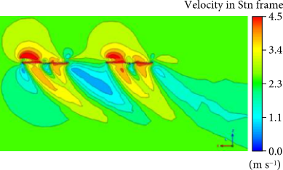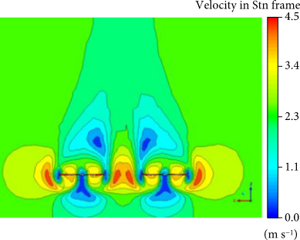

Vento vertical

With the influence of vertical wind, the original vortices without wind disturbance move upwards and deform, which causes the streamline to change from circumferential flow to axial flow. This may have a negative effect on the aerodynamic performance of the quadrotor, resulting in the reduction of thrust and the increment of power consumption

(outra)

The total thrust produced by the rotor decreases notably with increased wind speed in a given direction. As the angle of attack increases, the thrust variation due to wind speed decreases, as the component of wind velocity perpendicular to the rotor increases more slowly

Vento horizontal

 the thrust of quadrotor increases obviously (comparado ao sem vento)

Influencia do tamanho do drone no downwash:

.smaller rotor spacing-> the interaction between the downwash flows and the mutual induction between the wakes are very intense -> menos thrust e mais consume de energia. (1)

In [3], it is stated that quadrotors must avoid flying in the downwash of similar-sized or larger quadrotors because of the decrease in tracking performance and possible instabilite

Um drone maior deve voar debaixo do menor

when a rotor moves in forward flight the downwash becomes increasingly less turbulent, up to a point the blade tip vortexes are outrun by the aircraft, leaving the rotor operating in undisturbed air

**Mudança de massa - .**

The sudden change of mass and moment of inertia can be viewed as a “reset” of the controller. These parameters changed but if they remain constant thereafter, then we have proof that the path will be tracked and the closed-loop system is stable. (ProjReplace_2021_TIE_AdaptiveBacksteppingControlQuadcopter_postprint.pdf)

**Ground effect** [4]

Ground effect is negligible when the rotor is more than one diameter off the ground, z /R > 2 [W. Johnson. Helicopter Theory. Princeton University Press, Princeton, NJ, 1980.]

**R** is the radius of the rotor

**z** is the vertical distance from the ground

**T** is the thrust produced by the propeller in ground effect

**T∞** is the thrust produced at the same power outside of ground effect

V - relative velocity between the rotor and the surrounding air

v - velocity imparted by the rotor as the induced velocity

Rotor geometry

b – number of blades do rotor

a - is the lift curve slope

c is the blade chord.

θtip is the pitch angle at the blade tip,

